FAÇADE IMPROVEMENT
GRANT PROGRAM
FY 2023/24

Downtown Façade Improvement Grant Program
Project Guidelines

City of Sweetwater, Texas

A. Introduction
Sweetwater Economic Development has established the Façade Improvement Grant Program, which will provide financial assistance to property owners seeking to renovate or restore their exterior signage, lighting or commercial building facades. This program is designed to impact properties in need of revitalization, resulting in the improved exterior, visibility and presentation of a business in eligible districts. The program is not designed to subsidize corrections to building code violations that prolong the life of a commercial property.

The Façade Improvement Grant Program will provide a fifty percent (50%) not to exceed $15,000.00 reimbursement for the funding of the well-designed improvements which will coordinate all the important features of the storefront into a more attractive image while creating, if necessary, an accessible entrance for the public. This may include the restoration of architectural details, better windows and doors, and well-proportioned signage and lighting. Applicants will be responsible for hiring licensed professionals to refine their conceptual design depending on the scope of the work.

B. Definitions
The following definitions shall apply to the terms used in this Policy:

Applicant: The property owner signing the application for a Façade Improvement Grant.

Construction Costs: The cost of construction materials and installation labor. All other associated costs are deemed excluded, including but not exclusively, the following costs: design, construction document preparation, bidding, sweat equity and construction financing.

Eligible Enhancement: The improvements identified as eligible in Section C herein.

Façade: The portion of the building parallel to the primary right-of-way as determined by the City.

Project Coverage Eligibility Area:
- Downtown District: 9 square blocks around the Courthouse. 1st Street, Pecan Street, 4th Street, Elm Street.
- Main corridor: Elm Street, Broadway Street, Hailey Street, Lamar Street

Property: The physical lot and/or building to which improvements are being made.

Notice to Proceed: A written notice from the SEED MMD staff authorizing the applicant to begin construction as approved by the SEED MDD Board of Directors.

SEED MDD: Sweetwater Enterprise for Economic Development Municipal Development District

C. Eligibility Criteria
The following criteria must be met for participation in the Façade Improvement Grant Program:
- Any given property address must not have received, in aggregate, more than $15,000.00, in façade improvement grants from SEED MDD within the past ten (10) years.
- Applicants must be commercial property owners or nonprofit organizations located within the Downtown District or on a main corridor;
- Applicants must be up to date on all municipal taxes prior to participation in the program;
- Applicants must not have any City liens filed against any property owned by the Applicant; including but not limited to code enforcement liens or tax liens.
- Applicants must comply with all State and local laws and regulations pertaining to licensing, permits, building code and zoning requirements. Including, without limitation, the International Building Code (IBC) 2018 and the National Electrical Code (NEC) 2023 as adopted by the City of Sweetwater and incorporated into the Code of Ordinances of the City of Sweetwater, as amended from time to time, and all other requirements included in Code of Ordinances of the City of Sweetwater at the time of construction.
- Understanding that the overall objective of the program is to improve exterior, visibility and presentation of a property; the SEED MDD Board has the discretion to decline an application.

D. Design Principles and Guidelines
Improvements to be funded by the program must be compatible with the character and architecture of the individual building as well as meeting City standards with regards to latest construction and design trends. Buildings with historical significant architectural qualities are strongly encouraged to restore and maintain these features. Improvements for buildings not having such architectural features should be carefully considered and be seen as an opportunity to substantially enhance the appearance of the buildings and their streetscapes.

- Eligible Façade Improvements:
  - Restoration of details in a historically contributing or significant buildings, and removal of elements which cover architectural details;
  - Window replacement and window framing visible from street which is appropriately scaled to the building;
  - New City-Approved signage, including monument signage, wall and awning signage. All signage must comply with the City Sign ordinance.
  - Lighting which is visually appealing and appropriately illuminates signage, storefront window displays, and recessed areas of a building façade;
  - Awnings or canopies which can be both functional and visually appealing;
  - Curbing, irrigation, approved landscaping or other landscaping features attached to the building where appropriate;
  - Cleaning, painting or residing of the building;
  - New storefront construction, appropriately scaled within an existing building;
  - Other items which may not be listed above but would improve the front façade of the building.
- Ineligible Improvements/Expenses:
  - Exterior improvements located on the sides or rear of the building not visible from a public right-of-way;
  - Interior improvements;
  - Playground or recreational equipment;
  - Structural changes;
  - Burglar bars
  - Security Alarm System;
  - “Sweat Equity”;
  - New construction;
  - Furniture;
  - Architectural or other professional fees;
  - Asbestos testing, removal, abatement or remediation; or
  - Improvements for which insurance funds are received.
  - Improvements or replacements to the roof of the structure
  - Parking lot improvements
- Prior Improvements
Alterations and improvements made prior to receiving a “Notice to Proceed” are not eligible for reimbursement.

E. Program Assistance
Financial Assistance
Funding offered is a matching grant in which SEED MDD reimburses the applicant fifty percent (50%) of the total construction costs, up to $15,000.00 maximum match grant for façade improvements. Architectural design fees may not be included in the total cost of eligible improvements. In addition, the City of Sweetwater shall waive the divided portion of any building permit fee directly related to an approved project under this program. Applicant’s match may be in the form of other financial aid (grant or loan) receive from other agencies and/or banks, but my not be “in-kind”. SEED MDD will only provide reimbursement after the Applicant supplies all documentation showing payment has been made for the work done.

F. Procedures
All prospective applicants must follow the procedures in the order outlined below:
- Applicant meets with the Executive Director of SEED MDD for initial project discussion and submits application.
- Applicant’s design team submits proposed drawings to the SEED MDD staff for review.
- Applicant’s design team submits no fewer than one arms-length bids from contractors that include a reasonable price quote(s) with the application.
- The Executive Director may choose to return the application to Applicant for further refinement or clarification or present the proposed project to the SEED MDD Board of Directors for review at a regularly scheduled meeting in his/her discretion.
- The SEED MDD Board of Directors, upon receipt of the application from the Executive Director, reviews the application at a regularly scheduled meeting, determines if the application satisfies the Design Principals and Guidelines, and determines, in its sole and absolute discretion, if the proposed project represents an appropriate expenditure of SEED MDD funds and whether or not the proposed project will appropriately impact a property in need of revitalization, resulting in improved exterior visibility and presentation of the business in eligible district.
- If approved by the SEED MDD Board of Directors, Staff sends applicant “Notice to Proceed” and fully executed Façade Improvement Grant Agreement. Any work completed prior to receiving the “Notice to Proceed” will not be reimbursed.
- Applicant has 90 days from the date of the “Notice to Proceed” to begin implementation of approved improvements. Applicant must provide SEED MDD staff with copies of all building permits and certifications received from the improvement project.
- Contractor constructs project improvements as specified in the final design. Any changes to the approved plan must be approved by the SEED MDD staff and Board.
- The applicant will have 180 days to complete said project (from the Notice to Proceed date). Applicant can apply to staff for an extension on a case by case basis.
- Applicant notifies SEED MDD staff when project is complete. SEED MDD staff conducts necessary inspections to ensure improvements comply with final drawings and all necessary building and zoning codes.
- Applicant must submit copies of all paid invoices to SEED MDD staff, who then submits for reimbursement check.
- In the event the applicant is denied; the Applicant will not be allowed to reapply to the program for 90 days from the original application date.

G. Termination
SEED MDD has the right to terminate any agreement under the grant program if a participant is found to be in violation of any conditions set forth in these guidelines in accordance with the Façade Improvement Grant Agreement.

Office Use Only:
Date Submitted:
Approval Date:
Completion Date:
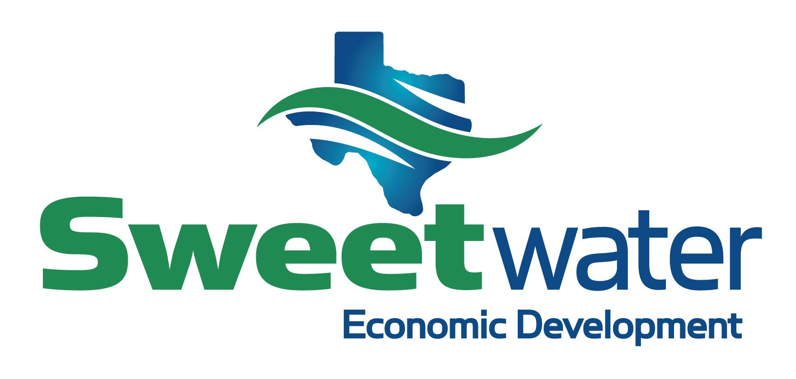
City of Sweetwater
Façade Improvement Grant Program Application

Applicant Name: | Business Name:
Mailing Address: | Project Address:  Email Address

Type of Work (Check all that apply)

Façade___ Signage___ Awnings____ Lighting____

Attach a narrative describing proposed improvements and how the improvements will complement the surrounding area.

Project Expenditures | Estimated Costs | Grant Requested
Façade/Building Rehab

Signage/Lighting

Architectural Elements

Landscaping

Other

Total

Total Cost of Proposed Project $____________________________

Total Grant Request
(May not exceed the lesser of 50% of total cost
or maximum of $15,000) $_____________________________

Attach final design drawings and photographs of building’s exterior façade.

Applicant Signature Date

Owner Signature Date
(if different from Applicant)

SEED MDD Representative Date
“Notice to Proceed”

